WINDOWS SERVICES

What is a Windows Service?

Windows Services are non UI software applications that run in the background. Windows services are usually starts when an operating system boots and scheduled to run in the background to execute some tasks. Windows services can also be started automatically or manually. You can also manually pause, stop and restart Windows services.

Windows service is a computer program that runs in the background to execute some tasks. Some examples of Windows services are auto update of Windows, check emails, print documents, SQL Server agent, file and folder scanning and indexing and so on. If you open your Task Manager and click on Services tab, you will see hundreds of services running on your machine. You can also see the statuses of these services. Some services are running, some have paused, and some have stopped. You can start, stop, and pause a service from here by right click on the service.

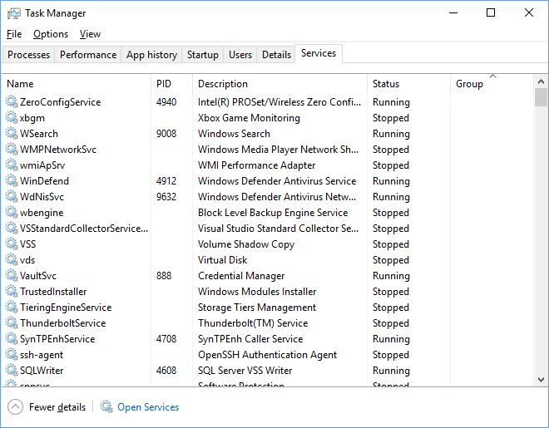

You may also find all services running on your machine in the following ways:

* Go to Control Panel select “Services” inside “Administrative Tools”.
* Open Run window (Window + R) and type services.msc and press ENTER.
* How to create a Windows service in C#?
* Let's create a Windows Service in C# using Visual Studio.
* **Step 1**
* Open Visual Studio, go to File > New and select Project. Now select new project from Dialog box and select “Window Service” and click on OK button.

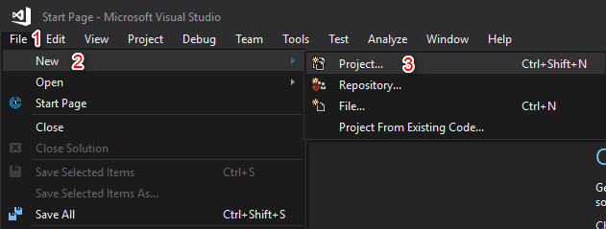

**Step 2**Go to Visual C# -> ”Windows Desktop” -> ”Windows Service” and give an appropriate name and then click OK

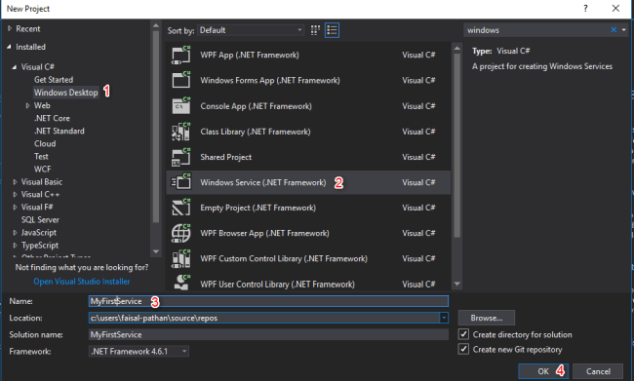

Once you click OK button the below screen will appear, which is your service

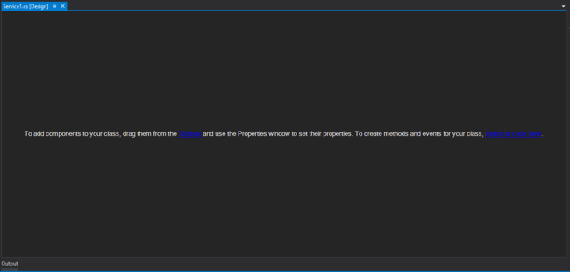

**Step 3**  
  
Right click on the blank area and select “Add Installer”

How to Add an Installer to a Windows Service

Before you can run a Windows Service, you need to install the Installer, which registers it with the Service Control Manager.

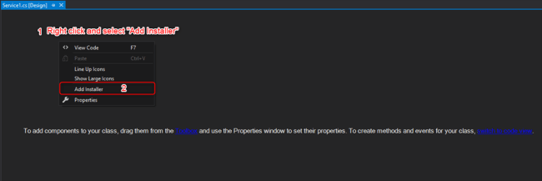

After Adding Installer, ProjectInstaller will add in your project and ProjectInstakker.cs file will be open. Don’t forgot to save everything (by pressing ctrl + shift + s key)

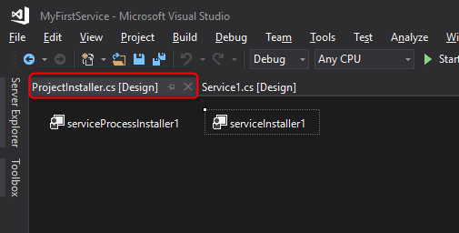

Solution Explore looks like this:

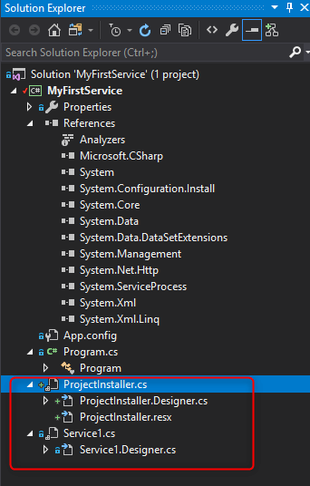

**Step 4**Right click on blank area and select “View Code”

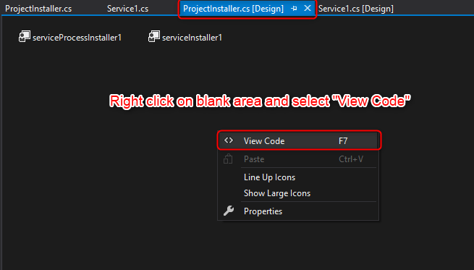

**Step 5**

Its has Construtor which contains InitializeComponent method:

The InitializeComponent method contains the logic which create and initializes the user interface objects dragged on the form surface and provided the Property Grid of Form Designer.

Very important: Don't ever try to call any method before the call of InitializeComponent method.

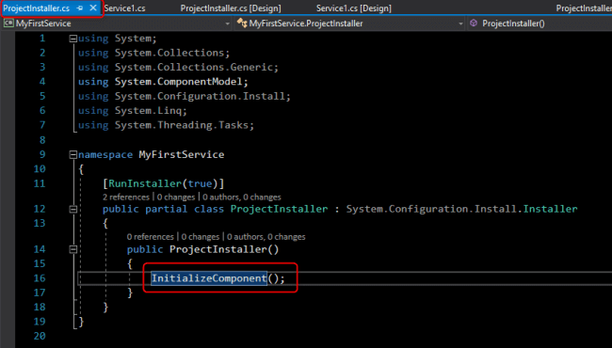

**Step 6**Select InitializeComponent method and press F12 key to go definition



**Step 7**Now add the below line:

this.serviceProcessInstaller1.Account = System.ServiceProcess.ServiceAccount.LocalSystem;

You also can add description and display service name (optionally).

1. **this**.serviceInstaller1.Description = "My First Service demo";
2. **this**.serviceInstaller1.DisplayName = "MyFirstService.Demo";

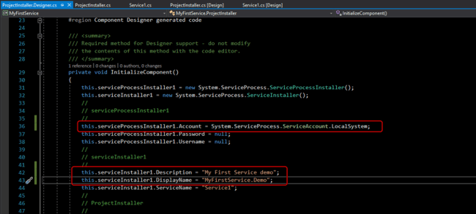

**Step 8**In this step, we will implement a timer, and code to call the service at a given time. We will create a text file and write current time in the text file using the service.

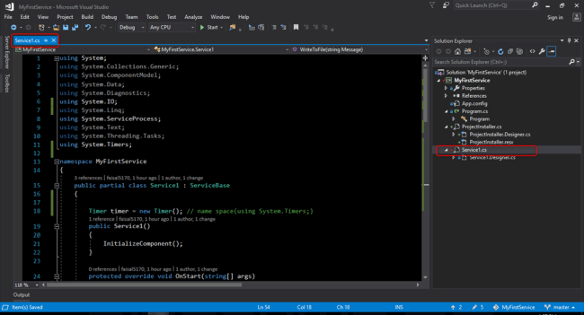

**Service1.cs class**

1. using System;
2. using System.Collections.Generic;
3. using System.ComponentModel;
4. using System.Data;
5. using System.Diagnostics;
6. using System.IO;
7. using System.Linq;
8. using System.ServiceProcess;
9. using System.Text;
10. using System.Threading.Tasks;
11. using System.Timers;
12. namespace MyFirstService {
13. **public** partial **class** Service1: ServiceBase {
14. Timer timer = **new** Timer(); // name space(using System.Timers;)
15. **public** Service1() {
16. InitializeComponent();
17. }
18. **protected** override **void** OnStart(string[] args) {
19. WriteToFile("Service is started at " + DateTime.Now);
20. timer.Elapsed += **new** ElapsedEventHandler(OnElapsedTime);
21. timer.Interval = 5000; //number in milisecinds
22. timer.Enabled = **true**;
23. }
24. **protected** override **void** OnStop() {
25. WriteToFile("Service is stopped at " + DateTime.Now);
26. }
27. **private** **void** OnElapsedTime(object source, ElapsedEventArgs e) {
28. WriteToFile("Service is recall at " + DateTime.Now);
29. }
30. **public** **void** WriteToFile(string Message) {
31. string path = AppDomain.CurrentDomain.BaseDirectory + "\\Logs";
32. **if** (!Directory.Exists(path)) {
33. Directory.CreateDirectory(path);
34. }
35. string filepath = AppDomain.CurrentDomain.BaseDirectory + "\\Logs\\ServiceLog_" + DateTime.Now.Date.ToShortDateString().Replace('/', '_') + ".txt";
36. **if** (!File.Exists(filepath)) {
37. // Create a file to write to.
38. using(StreamWriter sw = File.CreateText(filepath)) {
39. sw.WriteLine(Message);
40. }
41. } **else** {
42. using(StreamWriter sw = File.AppendText(filepath)) {
43. sw.WriteLine(Message);
44. }
45. }
46. }
47. }
48. }

Code explanation - the above code will call service every 5 seconds and create a folder if none exists and write our message.

**Step 9. Rebuild your application.**

Right click on your project or solution and select Rebuild.

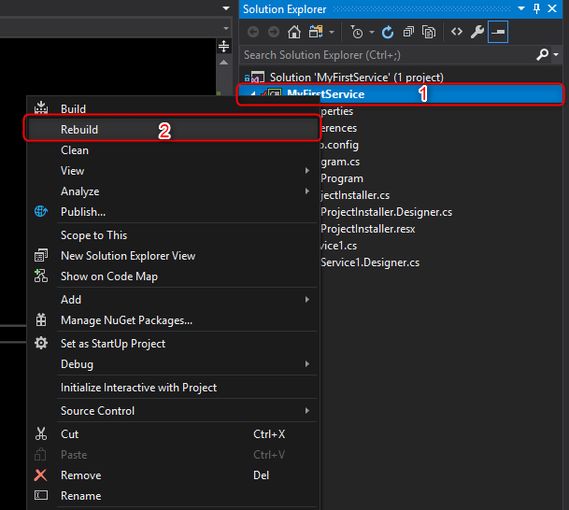

**Step 10**Search “command Prompt” and run as administrator

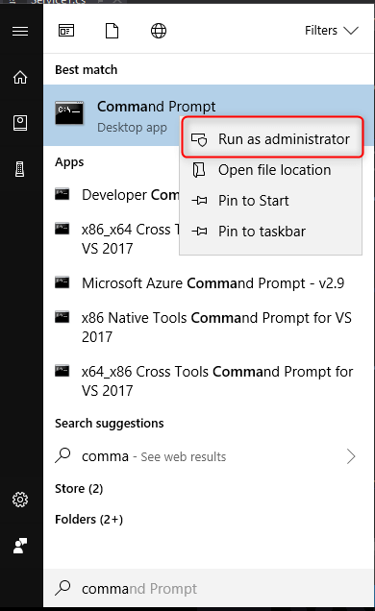

**Step 11**Fire the below command in the command prompt and press ENTER.

cd C:\Windows\Microsoft.NET\Framework\v4.0.30319

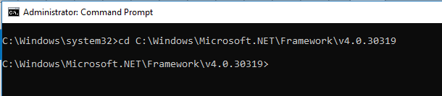

**Step 12**  
  
Now Go to your project source folder > bin > Debug and copy the full path of your Windows Service exe file.

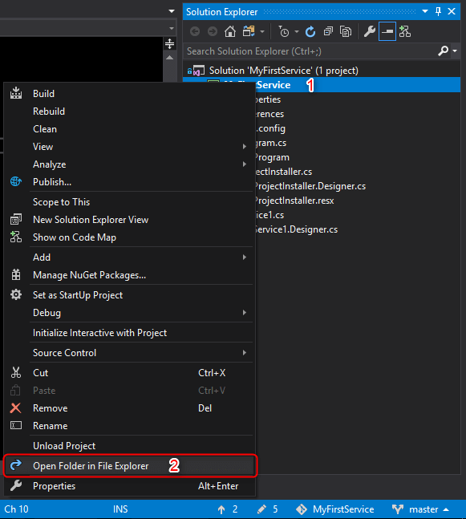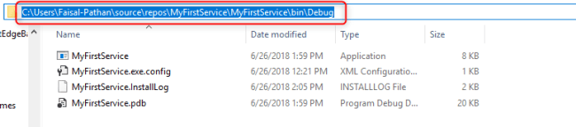

Installing a Windows Service

Open command prompt and fire the below command and press ENTER.

**Syntax**  
*InstallUtil.exe****+****Your copied path + \your service name + .exe*

**Our path**  
InstallUtil.exe C:\Users\Faisal-Pathan\source\repos\MyFirstService\MyFirstService\bin\Debug\MyFirstService.exe

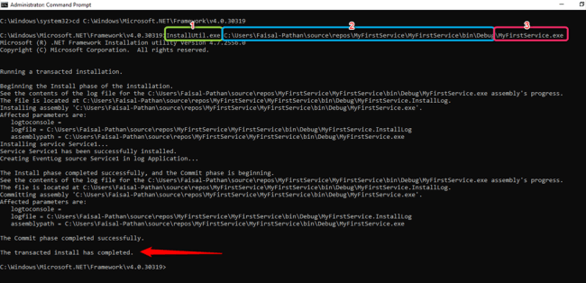

## Check status of a Windows Service

Open services by following the below steps:

1. Press Window key + R.
2. Type services.msc
3. Find your Service.

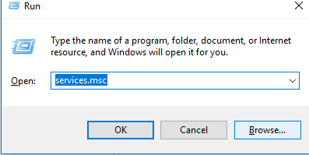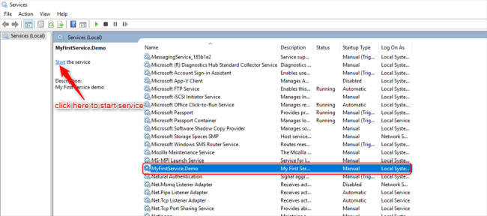

You may notice that the Windows service is running.

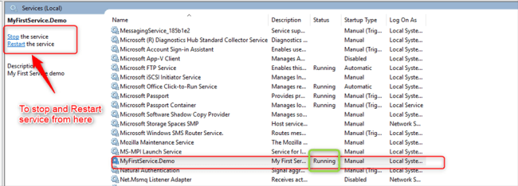

Check Windows Service Output

The service will create a text file with the following text in it.

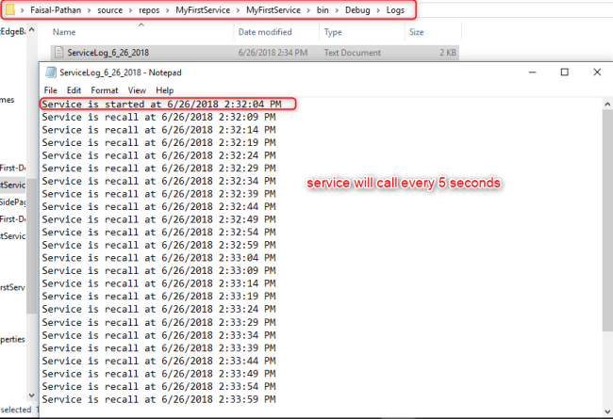

Log folder will be created in your bin folder.

## Uninstalling a Windows Service

If you want to uninstall your service, fire the below command.

1. Syntax InstallUtil.exe -u + Your copied path + \your service name + .exe
2. Our path InstallUtil.exe -u C:\Users\Faisal-Pathan\source\repos\MyFirstService\MyFirstService\bin\Debug\MyFirstService.exe